Lab 1 – Setting Up Flutter and Running Your First App
1. Objective
This lab helps students set up the Flutter environment and run their first Flutter application. Students will learn how to install tools, create a project, execute it on a device/emulator, and perform basic UI customization.
2. Requirements
Students must:
- Install Flutter SDK
- Configure IDE (Android Studio or VS Code)
- Create and run a Flutter app
- Customize the layout
- Submit screenshots as evidence
3. Guided Steps
Exercise 1 – Flutter Environment Setup
Goal: Install and verify Flutter tools.
Steps
- Install Flutter SDK.
- Add Flutter to PATH.
- Run:
flutter doctor
- Ensure all items are properly configured.
- Verify Flutter & Dart plugins in Android Studio.
Deliverables
- Screenshot of flutter doctor
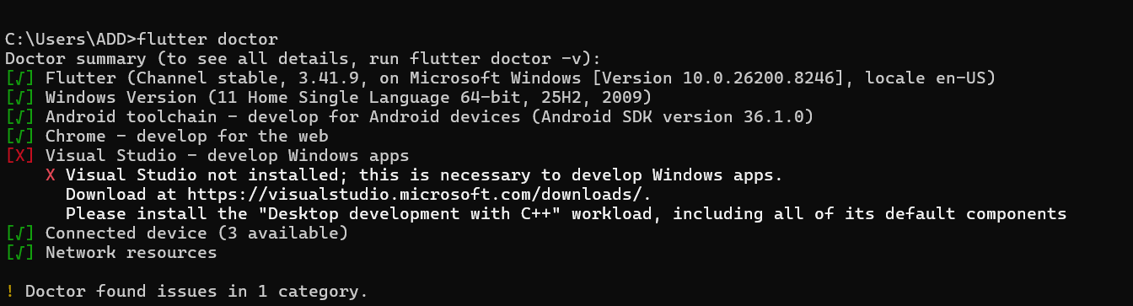
- Screenshot of Flutter/Dart plugin screen
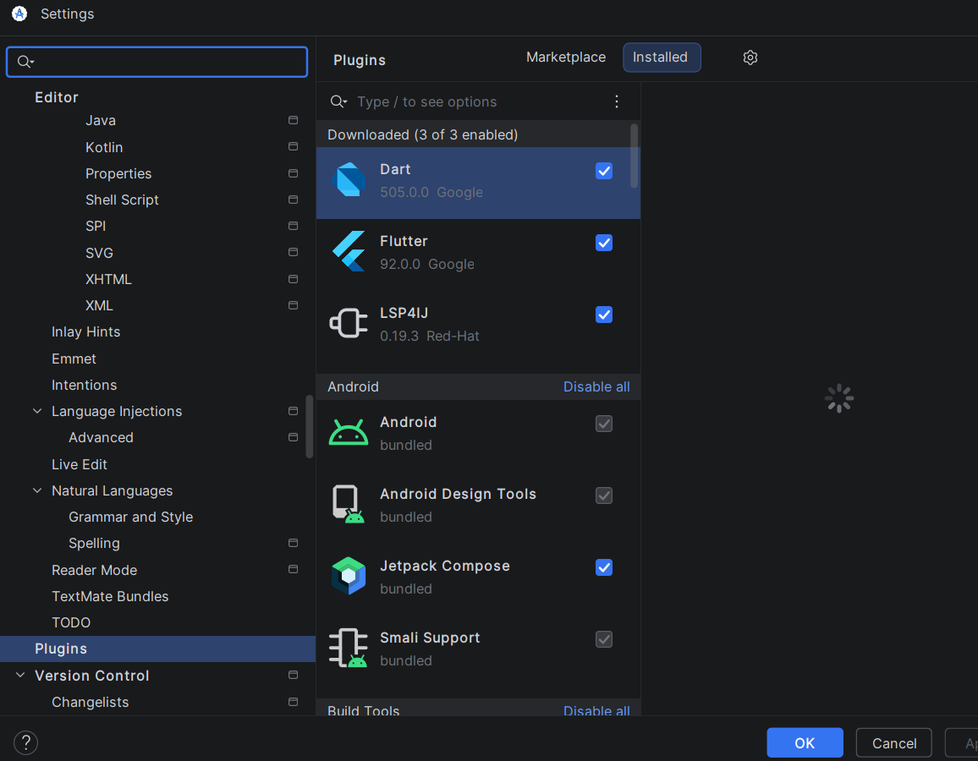

Exercise 2 – Create and Run Your First Flutter App
Goal: Learn how to create a Flutter project and run the default app.
Steps
- Open Android Studio → New Flutter Project
- Use project name: hello_flutter_lab1
- Explore key folders: lib/, android/, ios/, pubspec.yaml
- Start emulator or connect device
- Run the default counter app
- Modify the AppBar title in main.dart:
title: 'My First Flutter App',
- Use Hot Reload and observe changes
Deliverables
- Screenshot of project structure
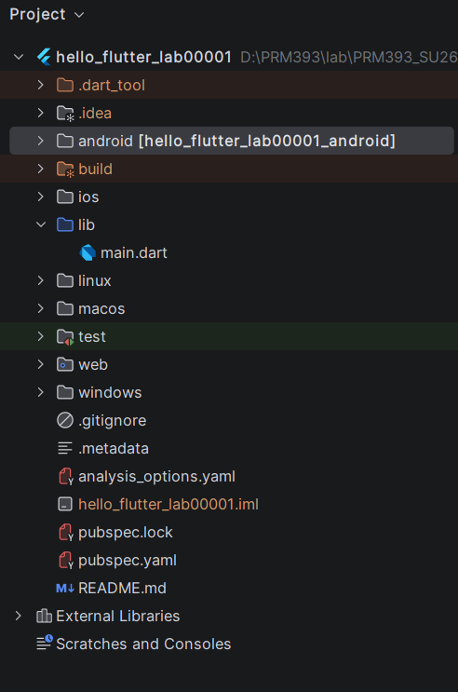
- Screenshot of running counter app
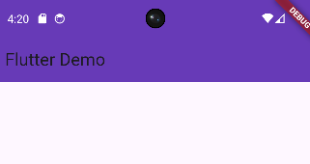
- Screenshot showing updated title via Hot Reload
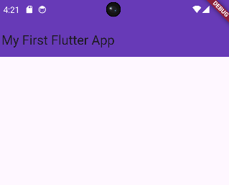
Exercise 3 – Customize Your First Flutter UI
Goal: Build a simple custom UI with widgets learned in class.
Steps
- Replace default code in main.dart with:
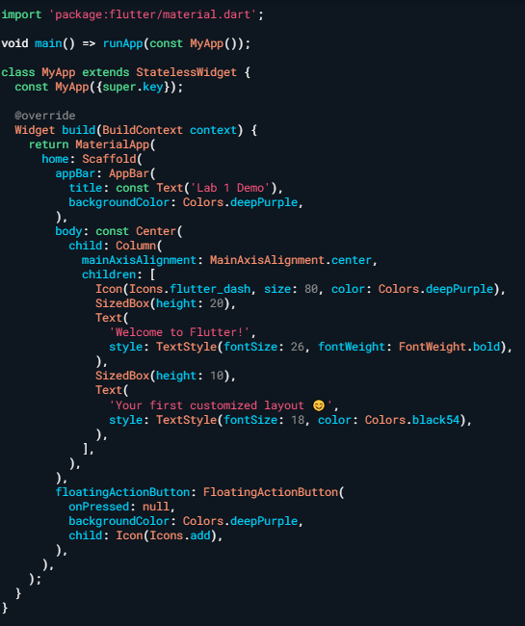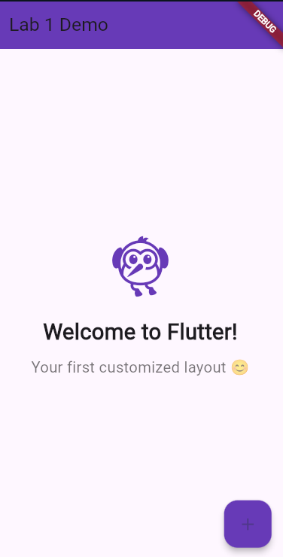
- Perform Hot Reload and verify UI updates.
- Modify colors/text and reload again.
Exercise 4 – Reflection Questions
- What is the purpose of the flutter doctor command?
- Flutter doctor is a diagnostic command that checks whether your Flutter development environment is set up correctly. It scans your system for required components such as the Flutter SDK, Android SDK, connected devices, and IDE plugins.
- What file acts as the entry point of a Flutter application?
- The file lib/main.dart is the entry point of a Flutter application. Specifically, the main() function inside this file is where the app starts execution, and it calls runApp() to launch the widget tree.
- Explain the difference between Hot Reload and Hot Restart.
- Hot Reload injects updated source code into the running Dart VM without restarting the app, preserving the current app state. Hot Restart, on the other hand, fully restarts the app from scratch, clearing all state and reinitializing everything from main().
- How does runApp() build the widget tree?
- runApp() takes a widget as its argument and sets it as the root of the widget tree. Flutter then calls the build() method on that widget, which returns a tree of child widgets. The framework traverses this tree, renders each widget onto the screen, and manages updates whenever the state changes.
- Describe how Flutter’s architecture enables cross-platform development.
- Flutter uses its own rendering engine (Skia/Impeller) to draw UI components directly onto a canvas, bypassing the native UI components of each platform. This means the same Dart code produces identical visuals on Android, iOS, Web, and Desktop. Platform-specific features are accessed through platform channels, allowing Flutter to communicate with native Android or iOS code when needed.
4. Expected Results
- Successful setup of Flutter environment
- Ability to create and run Flutter projects
- Understanding of widgets, layout, and hot reload
- Complete screenshots for all required steps

5. Submission
- Zipped Flutter project folder or GitHub link
- All screenshots
- Written answers for reflection questions

